Task 2:
NoSQL databases are designed to handle large volumes of stuctures or unstructured data. NoSQL databases stores data in a flexible, document-oriented format called BSON (binary JSON). Unlike SQL databases that use table and fixed schema, NoSQL databases are flexible schema. They excel in handling distributed data, providing horizontal scaling, and supporting use cases like real-time analytics, big data, and content management.
MongoDB is a popullar NoSQL database. MongoDB objects contain database, collections, documents, fields. Each document in MongoDB is a collection of key-value pairs, which can store arrays, nested documents, and various data types. MongoDB is widely appreciated for its scalability, high performance, and ease of use. It allows us to distribute data across multiple servers efficiently. MongoDB's flexibility eliminates the need for schema migrations, and it can be used in applications requiring quick iteration and dynamic development. It is ideal for use cases where data structures evolve over time, such as in e-commerce platforms, social networks, or real-time analytics systems.
Lesson 4 exercise 1:
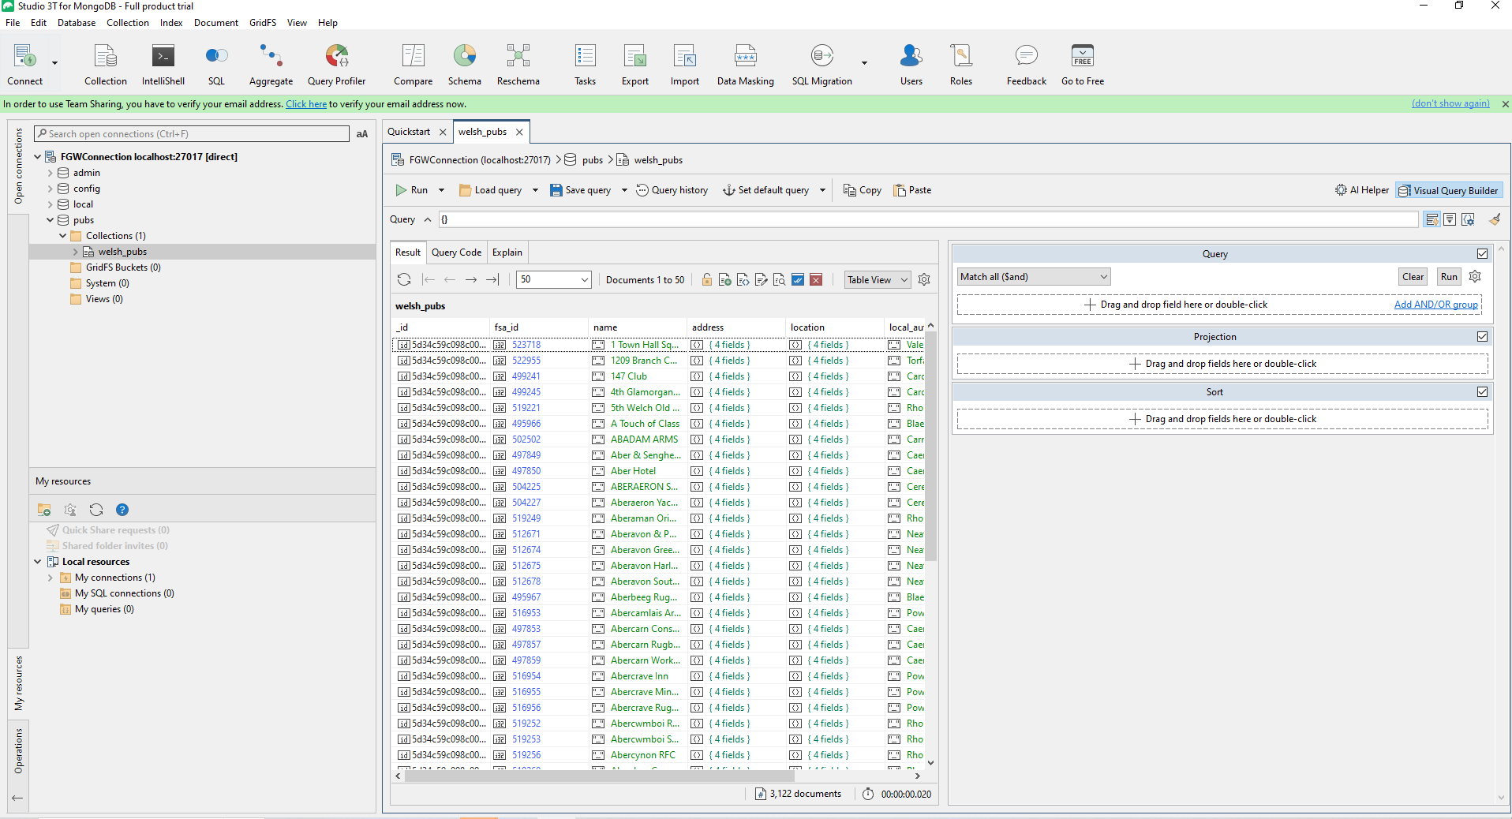
Import json document into the database
Lesson 4 Exercise 3:
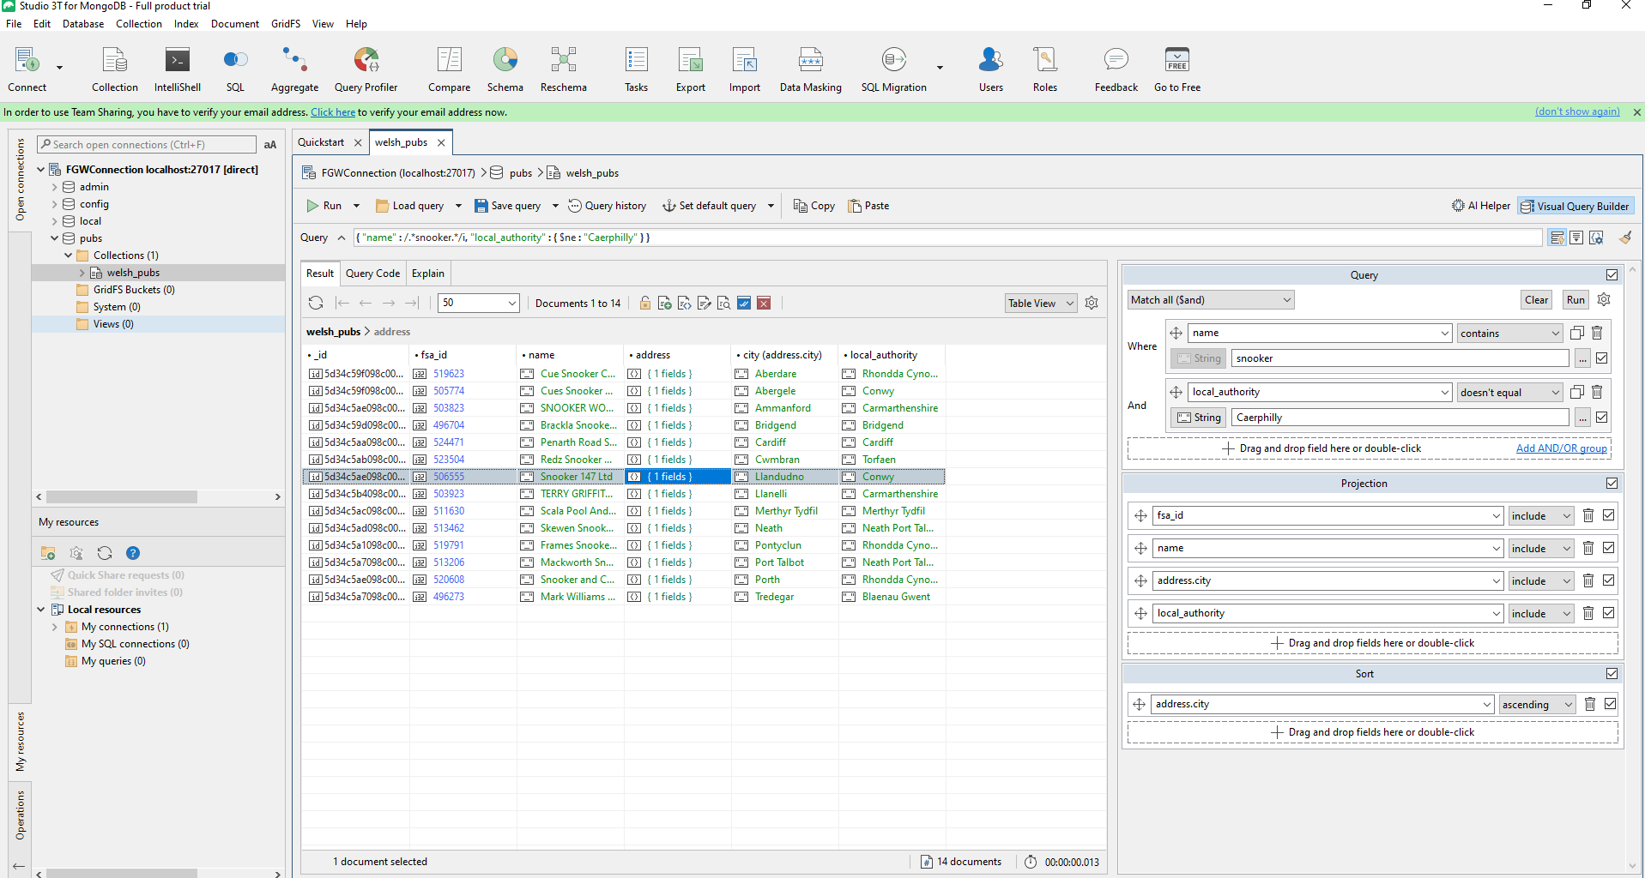
The Visual Query Builder in Studio allows us to build MongoDB queries visually by dragging and dropping fields, operators, and values, without the need to write code manually. We also can change value or datatype directly in study3t.
Lesson 5 Exercise 3:
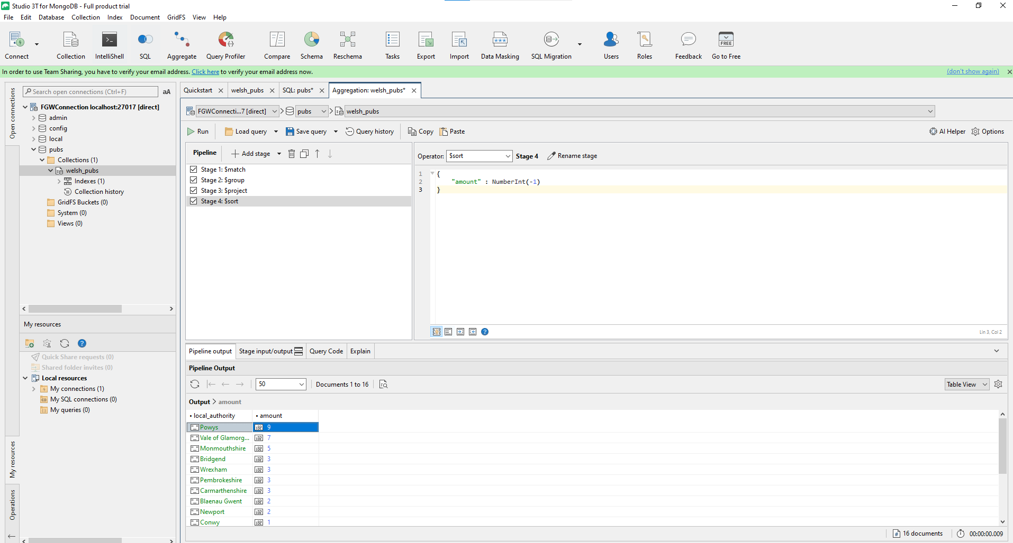
The Aggregation Editor in Studio 3T is a visual tool for building MongoDB aggregation queries without needing to write them manually. It simplifies the process of creating complex pipelines by allowing you to construct and modify queries step by step. In this, we can see the input and output of each stage, the flow of pipeline and switch the order of stage.
Lesson 6 Exercise 2:
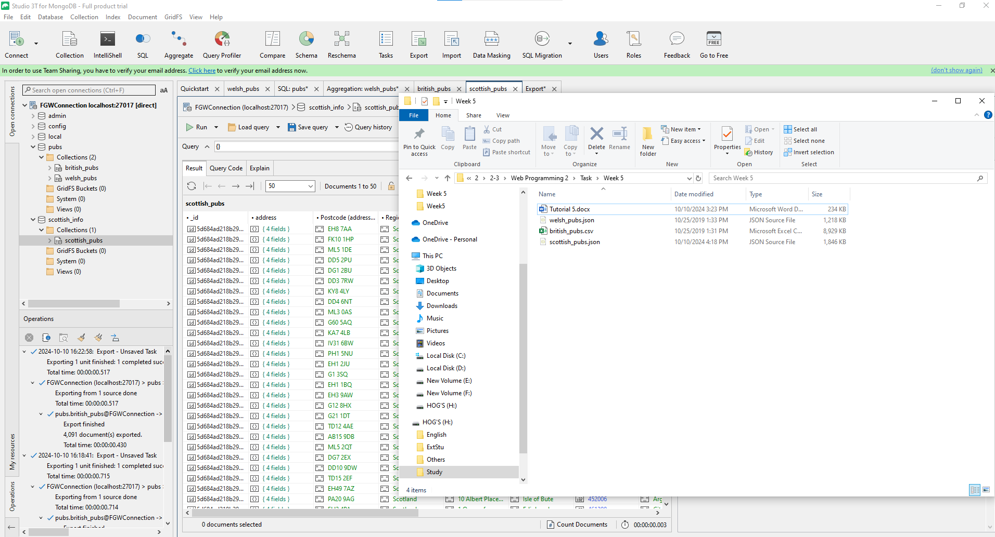
We can export into multiple database formats and import from other database into another database

